RISK ASSESSMENT FOR: | Use of Bouncy Castle / inflatable’s |  | 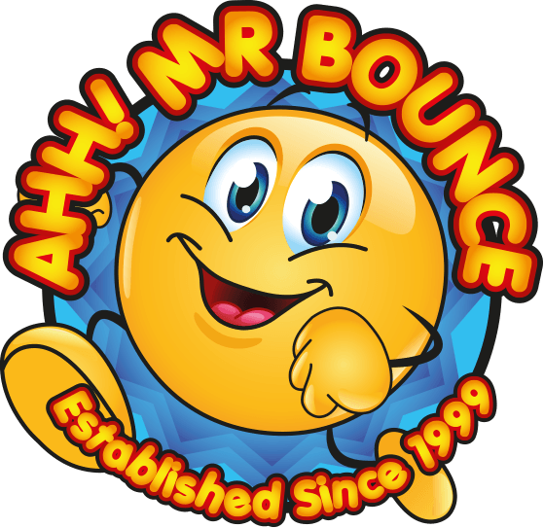
Establishment: | Assessment by: | Date:
1st Review Date Due : | Manager Approval: | Date:

Hazard / Risk | Who is at Risk? | How can the hazards cause harm? | Normal Control Measures | Are Normal Control Measures Y/N/NA
 |  |  |  | In Place | Adequate
Use of external companies / contractors  Inadequate insurance  Lack of competence | Parents  Pupils  Staff  Public | Accidents /property damage might not cover cost of repairs and personal injury claims. | - Vet for competence (member of a relevant association (AIMODS, NAIH or BIHA)  - Operator conforms to PIPA / ADIPS scheme  - Risk assessments provided  - Appropriate public liability insurance in place ( min £5m indemnity)
Using poorly maintained equipment | Parents  Pupils  Staff  Public | Electric shock / burns  Cuts / abrasions, broken limbs, muscular skeletal and other physical injuries | - Thoroughly examined every 14 months by a registered inspection body. The blower, inflatable and the electrical system should be examined and a certificate issued. These should be checked before use.  - Inspected prior to the first use on any day following supplier/ manufacturers instructions  - Inflatable has PIPA tag / current PIPA test certificate
Use of specialist equipment  Overloading equipment  Weather conditions  Instability / collapse of bouncy castle  Inadequate supervision  Inappropriate location of equipment | Parents  Pupils  Staff  Public | Slips /falls  Cuts / abrasions, broken limbs, muscular skeletal and other physical injuries | - Supplied / erected by competent persons.  - Barriers and adequate supervision to prevent unauthorised use and control access and egress.  - Limit on numbers / age / height etc using equipment. (equipment clearly marked as to its limitations of use).  - Sited in an appropriate location, well away from obstacles such as fences, sufficient room on site for inflatable and blower. (blower is at least 1.2 metres from the inflatable)  - Attendants must constantly watch the activities on the equipment.  - Attendants aware of basic rules for use e.g. all hard/sharp/dangerous objects such as footwear, buckles etc are removed; no bouncing on the front apron of the castle; no climbing or hanging on the outside walls etc.  - Equipment must not be used in high winds.  - All anchorage points must be used at all times. It must not be possible for the equipment to move around.
Manual Handling  Weighty, bulky and unwieldy load  Difficulties in getting a grip of the load  Individuals with pre-existing conditions  Physical Injury – difficult posture  Muscular skeletal disorders  Sprains / strains | Parents  Pupils  Staff  Public | Slips /falls  Cuts / abrasions, muscular skeletal and other physical injuries | - Sufficient number of people to move inflatable.  - Minimise carrying distance  - Individuals aware of correct lifting techniques

Additional Control Measures  (to take account of local/individual circumstances including changes such as working practices, equipment, staffing levels). | Action by Whom  (list the name of the person/people who have been designated to conduct actions) | Action by When  (set timescales for the completion of the actions – remember to prioritise them) | Action Completed  (record the actual date of completion for each action listed) | Residual Risk Rating
DATE OF REVIEW:  Record actual date of review | COMMENTS:  Record any comments reviewer wishes to make. Including recommendations for future reviews.
DATE OF  REVIEW: | COMMENTS:
DATE OF  REVIEW: | COMMENTS:

RESIDUAL RISK RATING | ACTION REQUIRED
VERY HIGH (VH) Strong likelihood of fatality / serious injury occurring | The activity must not take place at all.  You must identify further controls to reduce the risk rating.
HIGH (H) Possibility of fatality/serious injury occurring | You must identify further controls to reduce the risk rating.  Seek further advice, e.g. from your H&S Team
MEDIUM (M) Possibility of significant injury or over 3 day absence occurring | If it is not possible to lower risk further, you will need to consider the risk against the benefit. Monitor risk assessments at this rating more regularly and closely.
LOW (L) Possibility of minor injury only | No further action required.

